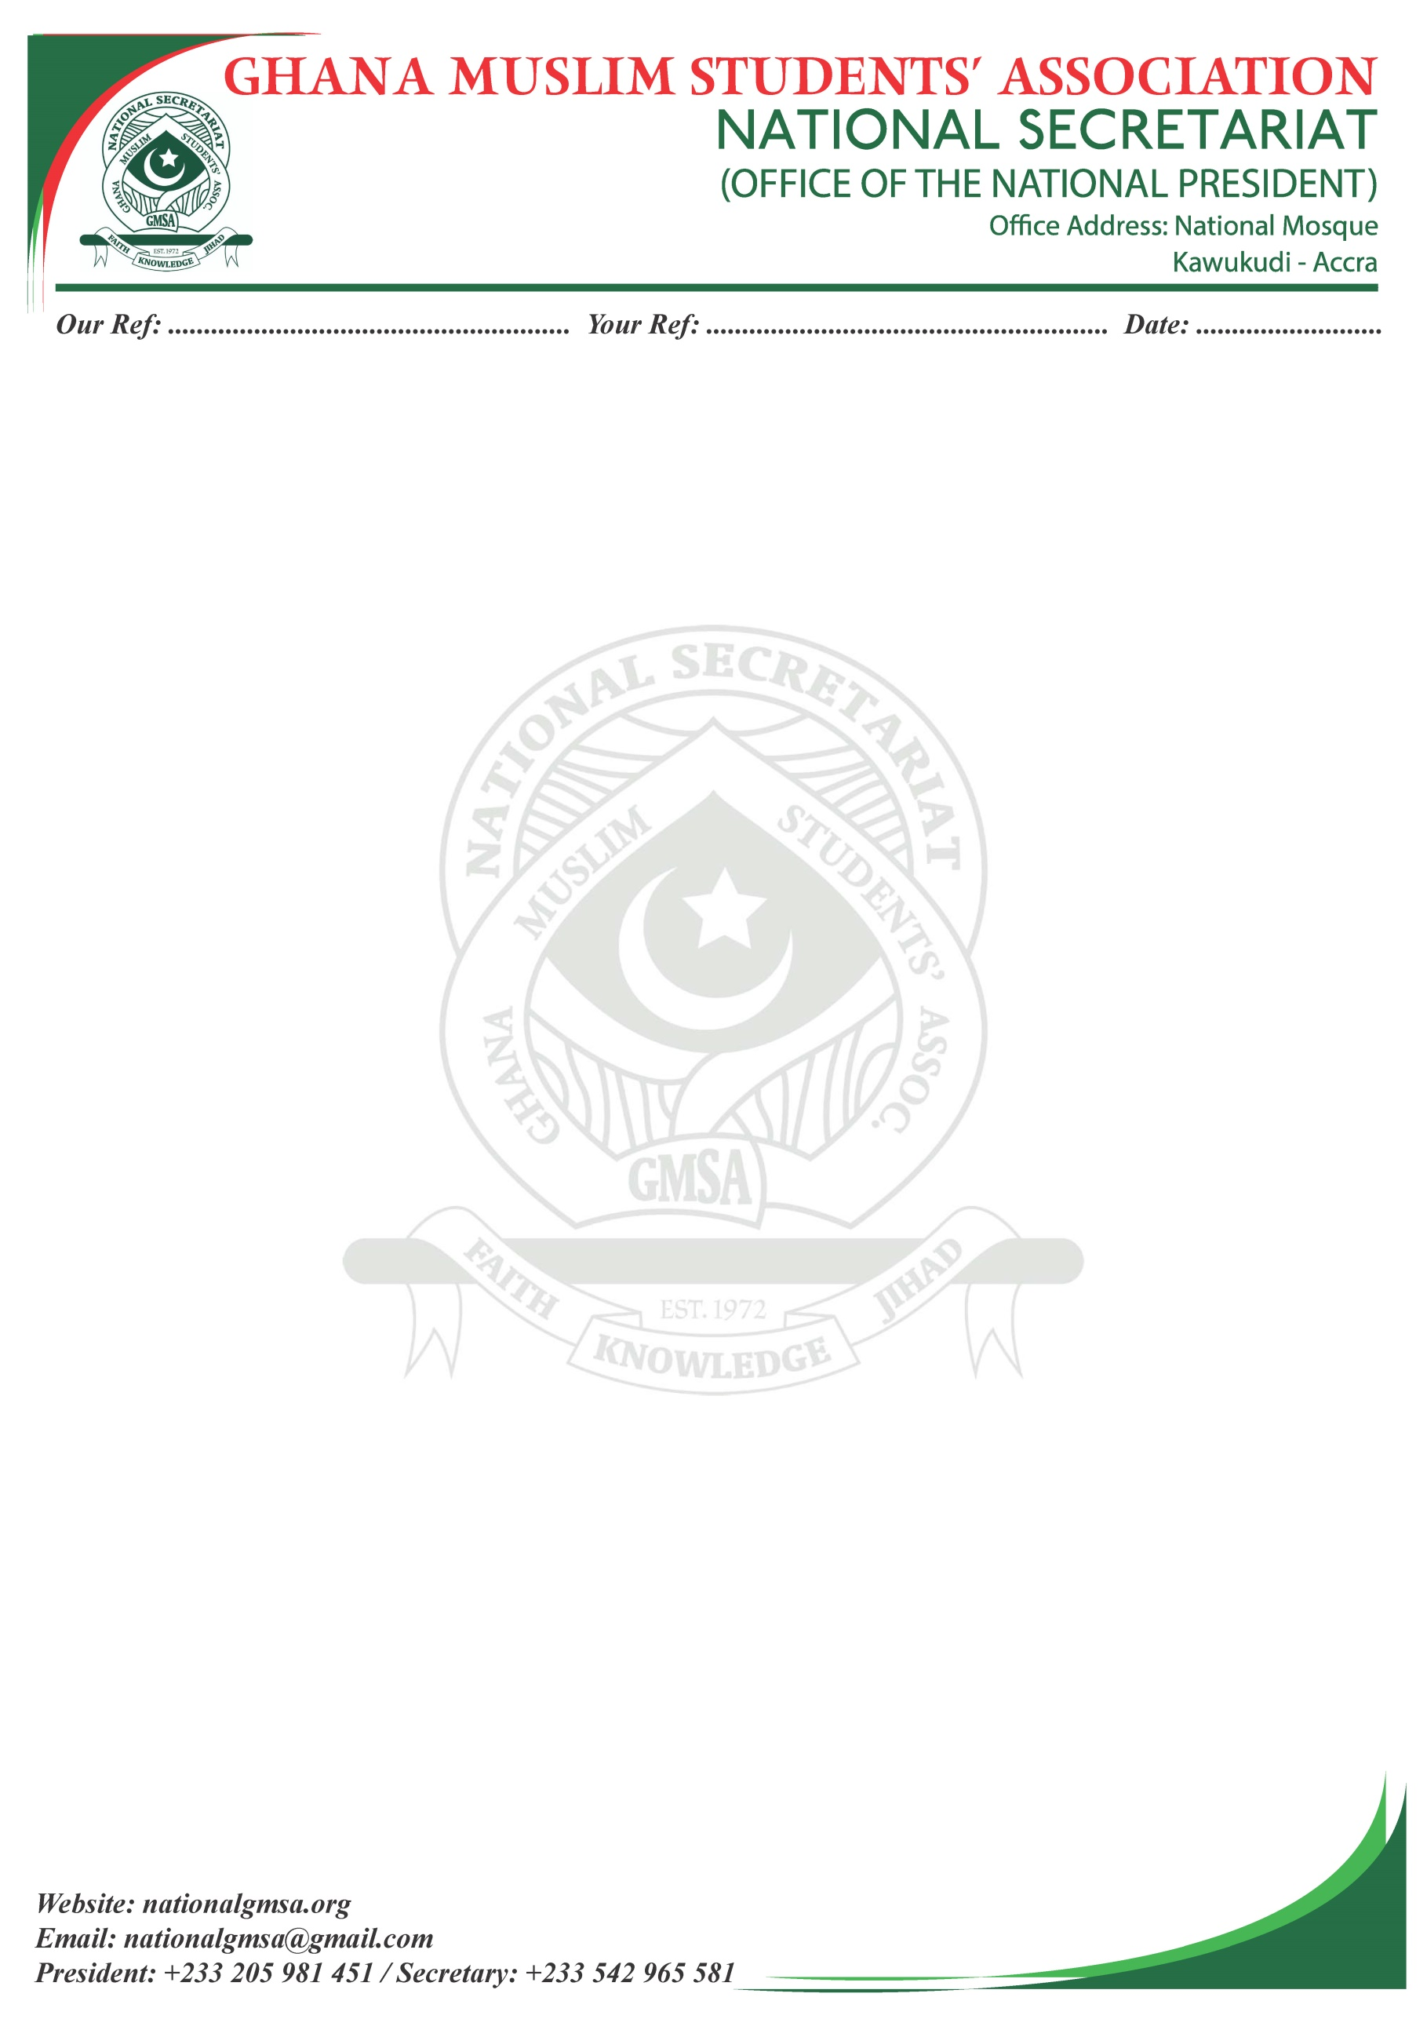

GMSA/NEC/27

15/09/24

Dear Sir,

**INVITATION TO INTERNATIONAL PEACE CONFERENCE AND CENTRAL COMMITTEE MEETING**

It is with great pleasure that I write on behalf of the Ghana Muslim Students Association (GMSA) to invite your esteemed institution to the upcoming International Peace Conference, which will be held in conjunction with our Central Committee Meeting. This joint event is scheduled to take place on 26th to the 27th October, 2024 at Chief Imam Conference center at the National Mosque, Ghana under the theme: "Empowering Muslim Youth for Sustainable Development, Peaceful Elections, and Democratic Politics."

As an institution dedicated to the promotion of education, dialogue, and the well-being of the Muslim community, your participation will be crucial in furthering discussions aimed at fostering peace, unity, and cooperation both within and beyond our borders. The conference will bring together students, scholars, leaders, and various stakeholders to engage in meaningful dialogue about pressing global issues, with the aim of promoting peace and understanding.

The Central Committee Meeting will, as always, serve as a platform for reflecting on the achievements of GMSA over the past year, setting goals for the future, and discussing important matters concerning the association’s growth and sustainability. Your insights and contributions during this meeting will be highly valued.

As stated in **Article 7(1)(c)** of the National constitution your institution is to be represented by the following delegation: **Presidents, Imams, Women commissioners and/or secretaries**.

Please confirm your participation by 27th September,2024 to allow us to make the necessary arrangements. Should you require any further information or have any questions, kindly contact me directly at **(+223542965581)** or Email address **nationalgmsa@gmail.com.**



Thank you for considering our invitation. We look forward to the opportunity of welcoming you and engaging in meaningful discussions that will shape the future of our youth and our communities.

Yours faithfully,



**Mr. Muhammed Abor Alhassan**

**National General Secretary**

**Phone No: +233-542965581**